If the server is 2016 and up, follow the below steps.

How to install .Net 3.5 to server 2016

Make sure/copy this file is on your desktop:

\\baz-filer02\MICRO\OPS\Software

SW_DVD9_Win_Svr_STD_Core_and_DataCtr_Core_2016_64Bit_English_-3_MLF_X21-30350.ISO

URL: <http://www.virtubytes.com/2017/02/03/install-net-framework-3-5-server-2016/> (additional notes)

In vSphere:

Click this disk/tool icon to mount the ISO

Then choose “Connect to ISO image on local disk”

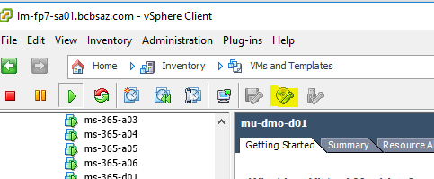

Then remote into the server

Once the server manger load up or click on the Server manager

Click the “Add roles and features

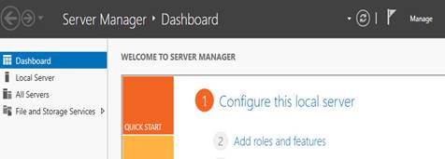

Pop up window should be show up (Wizard)

Click on the next 5x

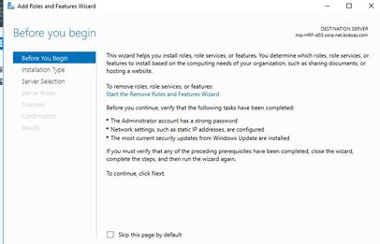

Check box the .net 3.5 - next

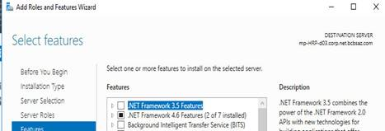

Click the Specify an alternate source path

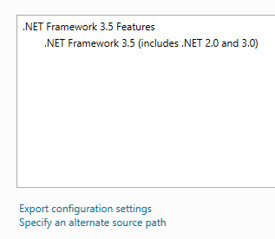

Type in the path E:\Sources\SxS

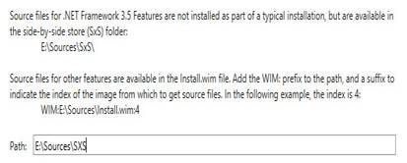

Click the install

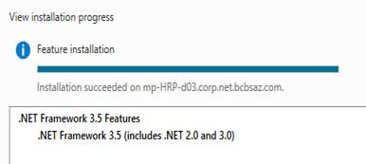

Then click the close (Wizard)

In vSphere:

Disconnect the ISO from the disk/tool icon



Click yes and then Ok

